**Comandos digitados**

git init  
git add .  
git commit  
git branch –M main  
git push –u origin main  
  
**Telas**

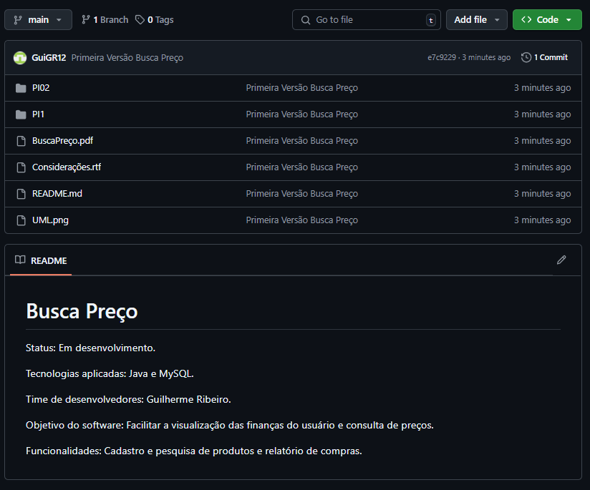

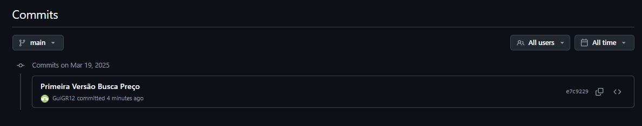

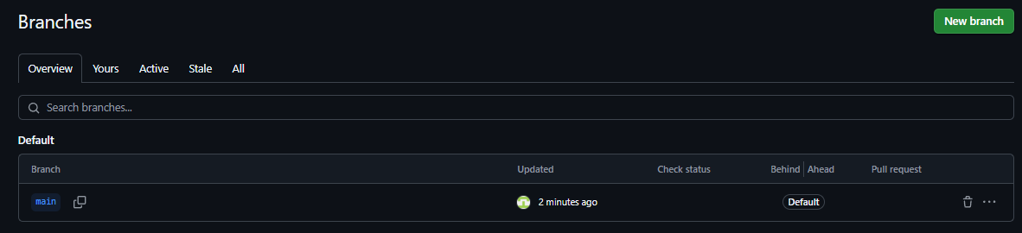

**Link do repositório remoto**

https://github.com/GuiGR12/PI2---Biusca-Pre-o